Third General Assembly
ENSURING THE SURVIVAL OF ISOLATED CULTURES AND THEIR HERITAGE

11th, 12th and 13th of March 2022
Gymnasium Haganum, The Hague

Forum: Third General Assembly
Issue: Ensuring the survival of isolated cultures and their heritage
Student Officer: Drishti Bhatnagar
Position: President of the Third General Assembly

Introduction
One of the chapters of the World Culture Report (2000) starts by stating “heritage conservation concerns the management, treatment, interpretation and fate of material heritage– old, beautiful or otherwise meaningful things such as buildings, objects and landscapes – and thus constitutes an important part of the sphere of material culture. Because all cultures practise some form of conservation, issues concerning cultural change are pressing matters for the conservation field worldwide.” It describes most beautifully what we, as humans, are trying to protect in order to preserve the very meaning of our existence and the way we live. Today's globalisation in the world, the need to connect everything to everyone, is leading to a kind of cultural unification, which is best seen in economically strong areas, such as Western Europe and the Arabian Peninsula. While it is an advantage that economic growth is greatly improved by this, the disadvantage is that among the goods exported, culture too is included; and therewith its loss.
The objective of this research report is to inform the General Assembly to such an extent that it is able to formulate a proper resolution for the preservation of isolated cultures under the threat of globalism.

Definition of Key Terms
Isolated Culture
Indigenous populations that are disconnected and isolated from the modern world. Examples include the Sentinel island population, and various Amazonian tribes.

Cultural heritage
UNESCO defines Cultural heritage as including artefacts, monuments, a group of buildings and sites, museums that have a diversity of values including symbolic, historic, artistic, aesthetic, ethnological or anthropological, scientific and social significance.

Natural heritage
The designation for places on Earth that are of outstanding universal value to humanity from the aesthetic or scientific point of view

Background Information

Historical context
Throughout the world, there are many indigenous and isolated populations, with unique cultures, that are threatened by expansion in our increasingly globalised world. These include assorted Amazonian tribes threatened by deforestation, the Massai in both Kenya and Tanzania are also facing hardships caused by global warming and habitat loss. The dense forests of Papua New Guinea are home to the Korowai people, who live in an area rich in natural resources. This has drawn the hazardous attention of mining, logging, and agricultural interests alike.
What makes these populations unique is that they are isolated. That is, they are disconnected from the modern world to a great extent. This has allowed them to develop at a vastly different pace compared to the globalised world. It has also protected their traditions, and customs to be preserved from modernization. Now that the modern world is a threat to such populations, they face more and more challenges every year. In many cases, the governments of the countries in question are not responding sufficiently enough to protect them, or at all. These cultures have been around far longer than the industrial revolution, and are a fascinating example of human history. The UN is a useful forum for nations to come together and agree upon suitable courses of action that can help to further protect these endangered cultures and their ancient heritages.
Culture is a part of the universal human experience, and it is a product of collaboration, and community. It is important for the integrity of the world that these indigenous, often uncontacted peoples are allowed to live in peace, as it is not just to strip away their homes, and tear apart their society that has existed for a far greater timespan than our own. Fortunately, there are organisations and UN member states who are making efforts to better protect such cultures, primarily through education. The United Nations Educational, Scientific, and Cultural Organisation (UNESCO) is an example of this, with their mission being to preserve this diversity of culture.
Protecting cultural heritage also includes natural heritage that is important to certain cultures. UNESCO defines Natural World Heritage as the designation for places on Earth that are of outstanding universal value to humanity from the aesthetic, cultural, historical, or an environmental point of view and as such, have been inscribed on the World Heritage List to be protected for future generations to appreciate.
In July 2013, the World Heritage Centre published a report in which it set out the guidelines that countries should adhere to in order to protect their heritage. The report provides a comprehensive framework tailored to assist in the implementation of the World Heritage Convention. Delegates may find that the framework could prove to be an invaluable reference when crafting a resolution.

Isolation of Native American Culture and Heritage
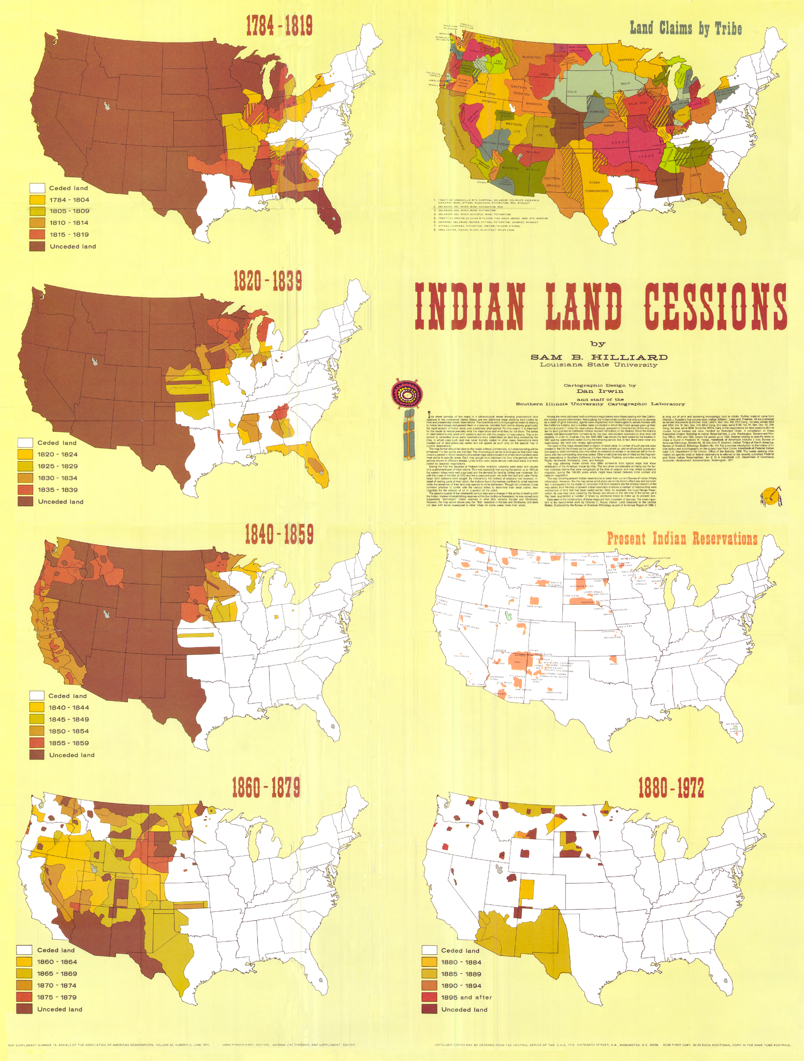
Native Americans are a key example when one is analysing the isolation of certain culture in modern society and the loss of heritage, especially in terms of historical land settlements. Ever since the westward expansion of the United States, native populations have been constantly displaced, shuffled between reservations while the size of their lands continues to dwindle. The photo on the left displays decline in Native American land over two centuries. In addition to disease brought on by colonisers, 18th century wars between native populations and white settlers caused tens of thousands of casualties on both sides, but the native population suffered the greatest losses. An 1894 estimate by the U.S. Bureau of Census recorded 30,000 cases of lost life on the side of the natives, yet estimated this number to be roughly fifty percent of the actual figure.
Aside from the many instances of mass violence against native populations that occured in the 19th century, many look to examples of modern isolation of native culture. Native Americans only received the full list of rights granted by the United States Bill of Rights in 1968 as a result of the groundbreaking Civil Rights Act. In addition to this, Native Americans have a lower median household income, lower rates of health insurance coverage, smaller population with a high school degree, and a disproportionate percentage of people with a higher education diploma when compared to the entire United States population.
Devastation Caused by Wildfires to Indigenous Lands in Brazil
The Amazon rainforest has suffered great losses in the amount of land to hundreds of thousands of fires each year. In 2021 alone the Legal Amazon Area in Brazil saw 102,000 wildfires. In 2005, it saw 264,000, the highest number in the past 17 years. A large portion of this land is indigenous land. It is suggested that delegates consider the differences between controlled and uncontrolled fires in the Amazon. Uncontrolled fires are considered to be provoked by natural, accidental, or criminal causes. Controlled fires are considered to be controlling fire intensity and limiting burning to a certain area.

Major Countries and Organisations Involved
United Nations Educational, Scientific and Cultural Organisation
UNESCO is the UN body responsible for the scientific and cultural educational preservation of our planet. These include both natural and man made phenomena.

Brazil

Brazil is home to several native Amazonian populations, and is currently failing to properly protect them.

Papua New Guinea

Unfortunately due to the expansion of illicit industries such as logging, mining, and agrarian, the indigenous peoples of Papua New Guinea are facing growing threats.

The United States of America

The American government has managed the locations and sizes of reservations for Native Americans and includes a branch known as the Bureau of Indian Affairs that's goal is to undo previous harm done to native peoples and ensure prosperity for future generations.

Timeline of Events
Date | Description of event
1831 | The Brazilian government enacts laws that revokes a declaration of “total war” on Indigenous peoples that was imposed by the Portuguese who ruled nine years prior.
July 2, 1968 | The American Civil Rights Act was signed into law by President Lyndon B. Johnson that allows Native Americans to have all of the rights listed by the Bill of Rights

October 5, 1988 | The Brazilian Constitution on the rights of Indigenous peoples is put into law, marking a major moment for Indigenous rights

January - August, 2019 | This time period saw an 88% increase in fires in Brazil’s Indigenous Lands when compared to the same time period the year prior

Relevant UN Treaties and Events
- Declaration on the Critical Economic Situation in Africa, 3 December 1984 (A/RES/39/29)
- Return or restitution of cultural property to the countries of origin, 11 November 1993 (A/RES/48/15)
- Rights of Indiginous Peoples, 23 November 2021 (A/76/459)

Previous Attempts to solve the Issue
In most countries with isolated indigenous populations present, there are policies designed to protect them and their interests, as well as ensuring they are left alone by tourists and members of the general public. However, as can clearly be seen, these policies are either undermined by their governments, or not enforced to the required extent.
Countries such as the United States have made attempts to apologise for past wrongdoings towards isolated cultures such as Native Americans and have specifically granted land to Native American tribes in order to help preserve their heritage.

Possible Solutions
In order to solve this issue, delegates could consider options that seek to implement preventative measures against the loss of culture such as adopting measures outlined by UNESCO that assist member states in the preservation of cultural heritage. Delegates could also consider assistance programs for minority groups facing isolation that would support the growth of their cultures and prevent further isolation through these programs. Delegates are also encouraged to consider solutions to environmental damages caused to isolated cultures such as indigenous peoples in the Amazon experiencing loss of cultural heritage due to wildfires.

Bibliography
Alves, Bruna. “Number of Wildfires in the Legal Amazon 2021.” Statista, 10 Jan. 2022, www.statista.com/statistics/1044328/number-wildfires-legal-amazon/.
Beauchamp, Zack. “The US’s Century-Long Destruction of Native American Land, in One Animated Map.” Vox, 23 Feb. 2015, www.vox.com/2015/2/23/8090157/native-american-theft.
“Cultural Heritage.” UNESCO, 22 June 2020, uis.unesco.org/en/glossary-term/cultural-heritage.
Mason, Randall, and Marta De La Torre. “Heritage Conservation and Values in Globalizing Societies.” UNESCO, 2000, unesdoc.unesco.org/ark:/48223/pf0000121094.
McCarthy, Robert J. “Civil Rights in Tribal Courts; the Indian Bill of Rights at 30 Years.” IDAHO LAW REVIEW 465, 1998.
“Native Americans and the US Census: How the Count Has Changed.” USAFacts, 21 Nov. 2019, usafacts.org/articles/native-americans-and-us-census-how-count-has-changed/.
Nilson, Tomas, and Kristina Thorell. Cultural Heritage Preservation: The Past, the Present and the Future. Halmstad University, 2018.
Rodrigues, Maria Guadalupe Moog. “Indigenous Rights in Democratic Brazil.” Human Rights Quarterly, vol. 24, no. 2, 2002, pp. 487–512, www.jstor.org/stable/20069611. Accessed 8 Mar. 2022.
Rorato, Ana C., et al. “Environmental Threats over Amazonian Indigenous Lands.” Land, vol. 10, no. 3, 6 Mar. 2021, p. 267, 10.3390/land10030267. Accessed 5 Apr. 2021.
The Office of the Prosecutor. Policy on Cultural Heritage. June 2021.
Thornton, Russell. “Native American Demographic and Tribal Survival into the Twenty-First Century.” American Studies, vol. 46, no. 3/4, 2005, pp. 23–38, www.jstor.org/stable/40643888. Accessed 8 Mar. 2022.
World Heritage Centre. Operational Guidelines for the Implementation of the World Heritage Convention. July 2013.

