General Assembly First Committee
The Taliban Crisis in Afghanistan

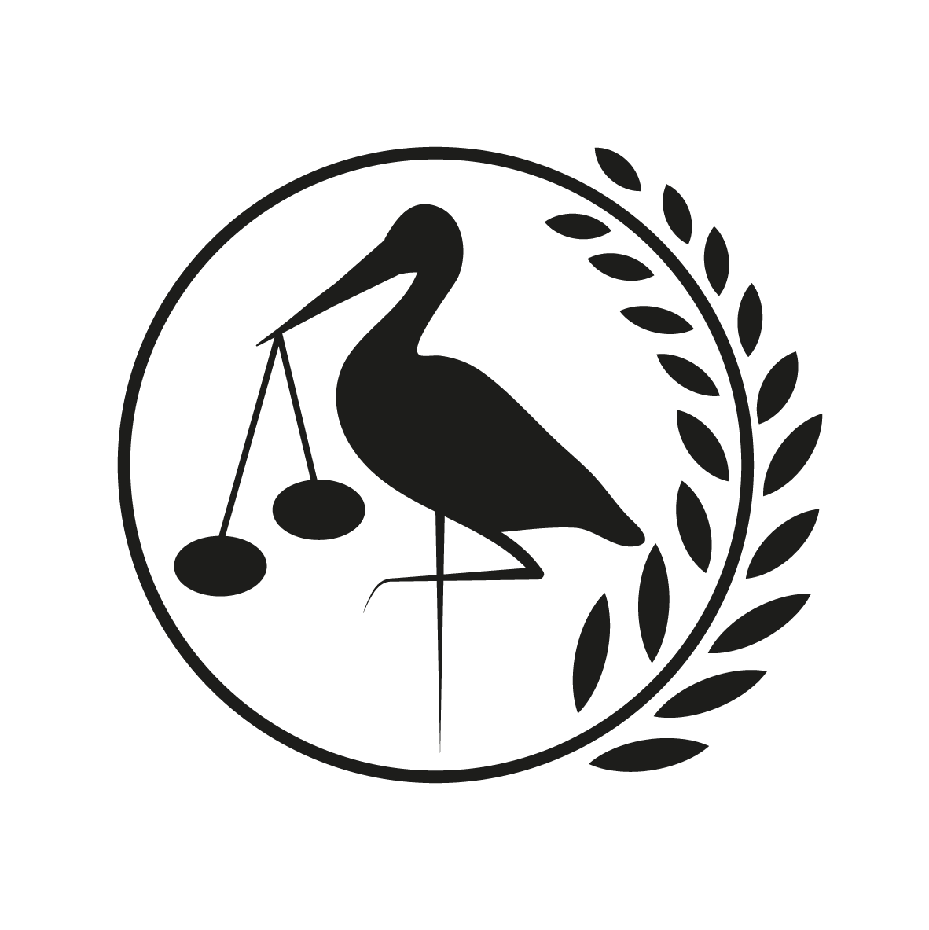
11th, 12th and 13th of March 2022
Gymnasium Haganum, The Hague

Forum: General Assembly First Committee (GA1)
Issue: The Taliban Crisis in Afghanistan

Student Officer: Jules Mateo-Nerlich
Position: President

Introduction
Afghanistan is a country whose history (especially in the last 50 years) is rooted in conflict. From the Soviet Union’s attempts to control Afghanistan and influence communism in the late 70s to late 80s, to the 9/11 terrorist attacks which caused a full scaled invasion from the United States of America, Afghanistan has not seen peace in a very long time. Last August (2021), the USA withdrew their troops from Afghanistan after 20 years of fighting. This withdrawal saw the Taliban overthrow the Afghan government and take over the country, essentially nullifying the US’s goal of turning Afghanistan into a free democratic country. Currently, the country is living in great poverty. The Taliban imposes strict islamic ideologies, which infringe basic human rights, especially those of women.

Definition of Key Terms
Terrorism
Terrorism is a threat or an action which poses risk to a government or to the public and is used to intimidate and influence them. Terrorists always have a motive which could be political, religious, racial or ideological, this makes them different to other crimes. To be a terrorist, one does not have to commit the attack, assisting or planning a terrorist attack are both also crimes which are prosecuted under the term ‘terrorism.’
War on Terror
A term used to describe the American-led global counterterrorism campaign launched in response to the terrorist attacks of September 11, 2001.

Background Information

War in Afghanistan

On September 11th, 2001, four commercial aeroplanes were hijacked by 19 al-Qaeda terrorists. The entire world was in shock as the hijacked aeroplanes were intentionally crashed into the World Trade Center in New York and into the Pentagon. Nearly 3,000 people died because of the terrorist attack that became known as ‘9/11’.

As a response to the tragic events that took place on September 11th, as well as several other terrorist attacks by al-Qaeda in the preceding years, President George W. Bush launched the global war on terror. The aim of this military campaign is to eliminate the threat that terrorist organizations pose on a global scale. In a speech in which President Bush announced the war on terror, he stated: “Our enemy is a radical network of terrorists and every government that supports them.” This referred to al-Qaeda but also to the Taliban as well as the country associated with these terrorist organizations, Afghanistan.

Not long after 9/11, President Bush demanded that the leader of the Taliban, Mullah Omar, would hand over Osama bin Laden, the leader of al-Qaeda. This ultimatum was refused, and as a result, an army of US-led forces invaded Afghanistan on October 7th, 2001. After just two months, the Taliban regime was overthrown, and Osama bin Laden was nearly captured before escaping to Pakistan. The power and influence of the Taliban and al-Qaeda were significantly weakened.

It is important to understand the geography of Afghanistan. The country is very vast and mountainous, with many places only being accessible by foot. This allowed for rebel Taliban soldiers to hide out in the mountains, causing US military presence (and thus the war) to rage on for 20 more years. President Joe Biden of the United States of America withdrew all American troops from Afghanistan in August. This caused a Taliban uprising which overthrew the government and which is until present day controlling the country once again.

Women’s rights
The current Taliban regime enforces a very strict interpretation of the Sharia (Islamic) law. This has seen women’s rights get completely neglected since last August. A very striking documentary by vice^{I} highlighted the difficulties that women are currently facing in Afghanistan. Some things it mentioned, is that women are not permitted to leave their household without their husband’s permission, are not allowed to work outside of the home and that violence against women has greatly increased (especially by those close to these women). One thing that was extremely shocking is that there is no possibility for these women to be heard as the court system works in such a way that if a man swears that he didn’t abuse a woman, then it did not happen.
Health and Economic situation in Afghanistan
Currently the situation in Afghanistan regarding health and its economy is extremely miserable. The Taliban is having many problems with forming a functioning government that is able to provide health services and economic opportunities to its citizens. Observing the current situation in Afghanistan, many say that it is turning into a humanitarian crisis as cases of famine, poverty, illness and infant death rise.

Major Countries and Organizations Involved
Afghanistan
Afghanistan obviously is a major country involved in this issue, seeing as the Taliban controls Afghanistan.
United States of America
Given the influence that the United States of America has had on Afghanistan in the last 20 years, it is undeniable that it is also a major country involved.
Al-Qaeda
The terrorist organization responsible for many terrorist acts against the US, including 9/11. The organization was based in Afghanistan and led by known terrorist Osama Bin Laden.
The Taliban
The Taliban is an Islamic fundamentalist group that took over the US-backed Afghan government in 2021, after 20 years of being at war with the United States.
Pakistan
Pakistan is a country bordering Afghanistan. Over the years, many Afghani Taliban soldiers have hid in Pakistan from the US. For example, the takeover of the government by the Taliban was organized and planned in Pakistan.

Timeline of Events
Date | Description of event
1995 | The Taliban rises to power in Afghanistan. It is an Islamic militia that upholds traditional Islamic values. They rise to power on a promise of peace. The United States does not recognize the authority of the Taliban. It is important to note that in the decades before, Afghanistan was dealing with war, famine and drought which made the idea of new leaders even more appealing.
September 11, 2001 | 9/11. Four different planes are hijacked and crashed into numerous locations in the United States, where thousands are killed. Osama Bin-Laden is seen as the prime suspect for coordinating this attack.
October 7, 2001 | The United States and Great Britain launch airstrikes and bomb Taliban targets in Afghanistan.
November 13, 2001 | Kabul Falls.
December 9, 2001 | The Taliban falls. Al-Qaeda leaders continue to hide in the mountains.
April 17, 2002 | The United States calls for the importance of rebuilding Afghanistan - they have major influence in the country.
May 1, 2011 | Osama Bin Laden is killed by American Military Forces in Pakistan
October 7, 2011 | This date marks the 10 year anniversary of the war.
November 17, 2020 | The United States announces troop withdrawals from Afghanistan.
August 15, 2021 | The Taliban takes control of Kabul, thus the Afghan government collapses.
August 30, 2021 | The 20 year war officially comes to an end as the last US troops have withdrawn. In the two weeks between the capture of the capital by the Taliban and the last withdrawal of US troops, more than 120,000 people were evacuated out of Afghanistan.
Present (2022) | The takeover of the Taliban has seen a major decrease in human rights, especially of those of women and girls.

Relevant UN Treaties and Events
- Security Council Resolution 2615 (2021)

Previous Attempts to solve the Issue
Due to the withdrawal of US troops being so recent there haven’t been any major attempts yet to solve the issue in Afghanistan right now. Nations have called upon the Taliban to protect human rights. The biggest attempt to solve the issue happened on February 25th 2022, when the Biden administration removed its economic sanctions on Afghanistan in hopes to better their economy to prevent a humanitarian crisis

Possible Solutions
When it comes to possible solutions for this issue there are a couple. First of all, for the time being all economic sanctions should be removed from Afghanistan. Also, humanitarian aid should be sent into Afghanistan by the red cross and supported by UN Member states, especially NATO countries.

The Afghan economy has to increase, meaning cash needs to be injected in it. This means that nations will have to continue to donate money to the country. States also have to see this as a humanitarian crisis first (and then deal with the Taliban after). An article by the United States Institute of Peace goes in more depth on how to restore the Afghan economy^{II}.

Bibliography
Works Cited
“Afghanistan Crisis: Taliban Expands ‘Food for Work’ Programme.” BBC News, 12 Jan. 2022, www.bbc.com/news/business-59961671.
Byrd, William. “How to Mitigate Afghanistan’s Economic and Humanitarian Crises.” United States Institute of Peace, 4 Jan. 2022, www.usip.org/publications/2022/01/how-mitigate-afghanistans-economic-and-humanitarian-crises.
Council on Foreign Relations. “A Timeline of the U.S. War in Afghanistan.” Council on Foreign Relations, 2021, www.cfr.org/timeline/us-war-afghanistan.
PBS. “A Historical Timeline of Afghanistan.” PBS NewsHour, PBS, 31 Dec. 2014, www.pbs.org/newshour/politics/asia-jan-june11-timeline-afghanistan.
Savage, Charlie. “U.S. Eases Sanctions to Allow Routine Transactions with Afghan Government.” The New York Times, 26 Feb. 2022, www.nytimes.com/2022/02/25/us/politics/us-sanctions-afghanistan.html. Accessed 8 Mar. 2022.
VICE News. “Life in the Taliban’s Afghanistan.” Www.youtube.com, 13 Feb. 2022, www.youtube.com/watch?v=iIFi_Rgm-T8.
Witte, Griff. “Afghanistan War | History, Combatants, Facts, & Timeline.” Encyclopædia Britannica, 23 Jan. 2019, www.britannica.com/event/Afghanistan-War.

Appendix or Appendices
Background Information:
^{I} Vice Documentary: https://www.youtube.com/watch?v=iIFi_Rgm-T8
(I really recommend you watch this documentary)

Possible Solutions ^{II}https://www.usip.org/publications/2022/01/how-mitigate-afghanistans-economic-and-humanitarian-crises

