General Assembly 6
The question of the legality and the consequence of ecocide
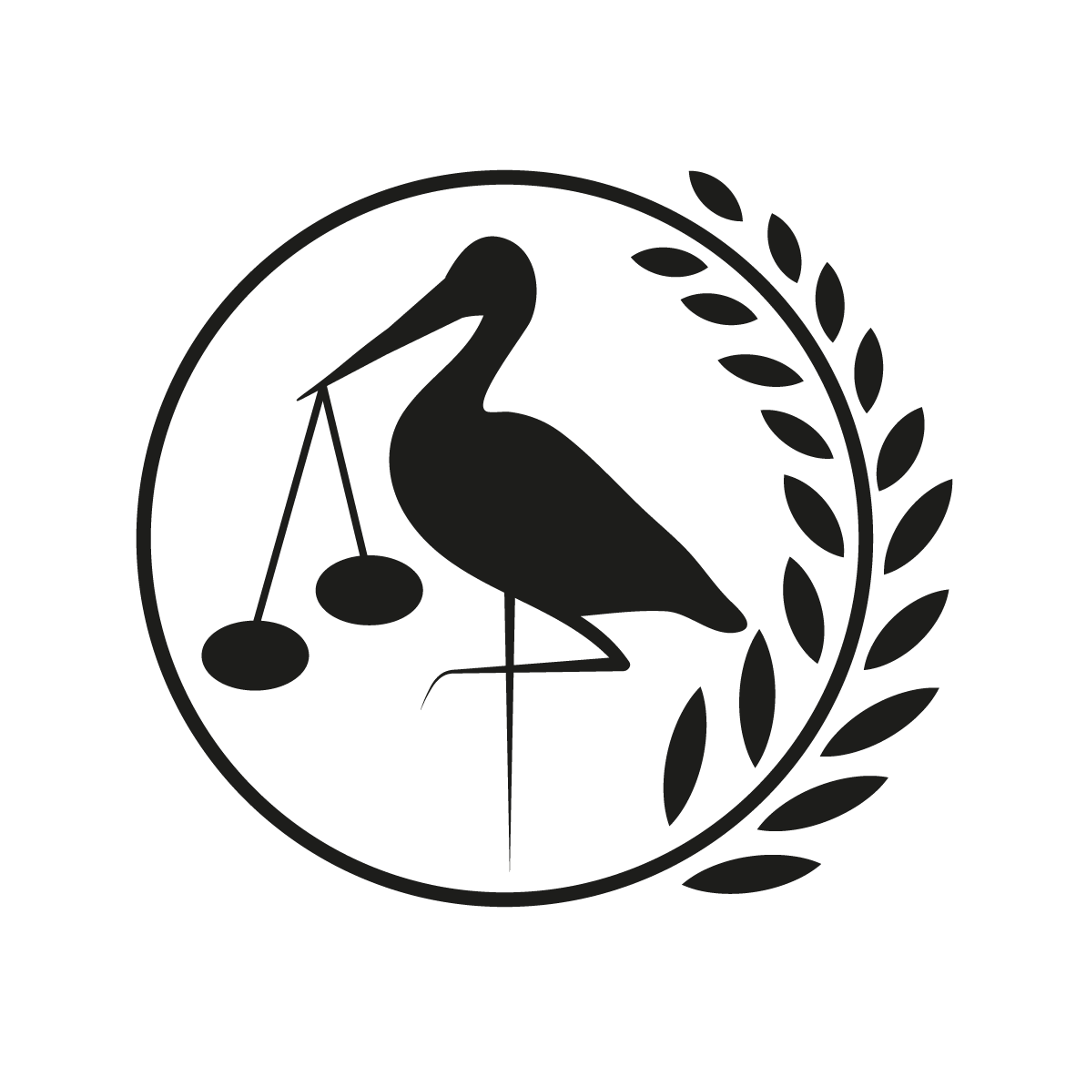
6th, 7th and 8th of March 2020
Gymnasium Haganum, The Hague

Forum: General Assembly 6
Issue: The question of the legality and the consequence of ecocide
Student Officer: Neri Weevers
Position: Head chair

Introduction
Now that climate change has become an urgent problem the question of the legality of ecocide has risen again. The term ‘ecocide’ is not a recent invention, it has been around since the 1970s where it was first publicly referred to by the Swedish prime minister Olof Palme at the Conference on War and National Responsibility in Washington with respect to environmental damage incurred during the Vietnam war. The process of making ecocide a crime at the International Criminal Court (ICC) is the work of Earth lawyer Polly Higgins, who said: “There is a missing responsibility to protect … What is required is an expansion of our collective duty of care to protect the natural living world and all life. International ecocide crime is a law to protect the Earth.”. Polly Higgins died in 2019 after a rapid cancer. She was a criminal barrister, a prolific writer and a passionate speaker on ecocide and the importance of protecting the Earth. Her influence has been profound, as she worked internationally with other lawyers, academics and environmentalists.
Ecocide is not only a crime against humans, it is also a crime against the Earth itself. Ecocide covers the direct damage caused to the Earth’s land, sea and river systems, as well as the flora and fauna within the affected ecosystems and the resultant impact on the climate. The harm of ecocide can however also be cultural and/ or emotional and it can affect communities at a deep level, especially when a way of life is profoundly and/ or practically connected to the affected ecosystem.
If a law is made that makes ecocide a crime, it will not only act as a brake on the companies themselves by making senior executives individually criminally responsible, it will furthermore discourage government ministers issuing permits for it, since they too will be individually criminally responsible, banks lending on it, investors from backing it and insurers form underwriting it. This means that the whole infrastructure which makes these practices possible, will be seriously weekend. This law will be a strong deterrent against ecocidal practices and it will be the catalyst for finding new, sustainable ways of operating. Currently civil litigation is the means by which we hold companies and states accountable for environmental harm. This is important, but it has limited scope for changing corporate practice, especially since existing laws put the interest of the shareholder first – companies are under a duty to maximise profit, sometimes the individuals responsible for environmental damage are even honoured for their contributions to the economy.
At this moment there is no international legally binding duty of care towards the Earth. There may be local, national environmental laws and regulations in individual countries, but these are regularly violated, often with the consent of those in government who issue permits to pollute. The process of establishing an international crime is by amending the 1998 Rome Statute, which established the ICC, to include a crime of ecocide to sit alongside the other four international crimes: genocide, crimes against humanity, war crimes, and crimes of aggression. Although an ecocide amendment has yet to be proposed, two sovereign states (Vanuatu and the Maldives) have now publicly called for consideration of such an amendment, this happened December 2019 at the Assembly of States Parties to the Rome Statute in The Hague.
After the successful Urgenda case in the Netherlands, where a judge ruled that the government’s efforts to fight climate change were inadequate and emissions cuts must be stepped up, several other legal organisations are now fighting for the environment in the courts. Campaigners have stated that an ecocide law would take these and other campaigns to protect nature to new levels. George Monbiot, columnist for The Guardian, wrote that it could make the difference between a habitable and uninhabitable world by shifting the balance of power and forcing executives to think twice about actions that might damage the planet.

Definition of Key Terms
Ecocide
As a broad generalisation, ecocide is defined first and foremost by the destruction, degradation and demolishment of ecosystems and specific environments, with harmful consequences for the living creatures to which they are home. When this occurs due to particular types of human activity, ecocide also becomes terminology that describes a particular form of criminality.
International Criminal Court (ICC)
The ICC investigates and, where warranted, tries individuals charged with the gravest crimes of concern to the international community: genocide, war crimes, crimes against humanity and the crime of aggression. The ICC is governed by an international treaty called the Rome Statute and is the world’s first permanent international criminal court. It is classified as a Court of last resort – to be used when a state is either unwilling or unable to bring their prosecutions for international crimes.

Background Information
Industries from all over the world have always been polluting the environment, but with climate change becoming such a pressing issue in such a short time, they are now frowned upon for their actions. Examples of massive scale environmental destruction by industries all over the world are the Athabasca oil sands, where tailing ponds in Alberta’s oil sands region are some of the biggest human-made structures on Earth and large enough to be seen from space. They contain a toxic slurry of heavy metals and hydrocarbons from the bitumen separation process. The nickel mines in arctic Sweden are poisoning the ancient grazing lands of the Sami community and threatening their livelihoods. The Amazon deforestation, the Amazon produces more than twenty percent of the world’s oxygen and yet it is being felled at a rate of one football pitch every second, more on this topic can be found in the research report on the issue of developing an international framework for legal responsibility regarding the situation in the Amazon region. In 2017 CDP published a report that shows that just one hundred companies are responsible for over seventy percent of industrial greenhouse gas emissions since 1988.
Operational and product greenhouse gas emissions of 25 active fossil fuel producing entities, 1988-2015
A law against ecocide will not only create a legal duty of care for the environment but also for communities, for future generations and for the wider life of our Earth. The so-called Carbon Major industries exacerbate climate change to such a degree that the lives and livelihoods of millions of people, particularly in the low-lying Pacific Island States, are under threat.
Different kinds of laws
There are many different ways in which we can combat ecocide. This can be on a national or an international basis and with hard consequences or not.
Soft laws
On an international basis, there are agreements, such as the Paris Agreement, the UN Global Compact and the UN’s Sustainable Development Goals which attempt to regulate polluting emissions. The problem with these soft laws is that they do not prevent serious harm for the simple reason that they are voluntary and cannot be enforced. We have seen the United States of America withdrawing from the Paris Agreement, which is in their rights. Therefore these laws or agreements can be a step in the right direction, but they will not be able to make a major difference.
Civil law
A civil law needs to be instigated by those individuals or communities affected by the environmental destruction; these individuals and communities are very often poor and without the resources to take such action against the wealthy and powerful polluters. Even if these corporations are ultimately forced to pay compensation, they can continue their ecocidal business practices. Such compensation payments are seen simply as a cost of doing business. This means that these kinds of laws have not been successful in stopping ecocide either.
National criminal law
The state comes into play when looking at these kinds of laws through their basic function, which is to prevent harm. There are penalties for certain environmental crimes, but often these are directed at companies rather than individuals, as companies are easier targets. Criminal law in developing countries is often less robust and less able to protect the environment.
Current situation
On a national basis, individual countries have their own laws, civil and criminal, regulating environmental damage, these laws are however too limited in the protection they provide. Existing international declarations, treaties and protocols do not impose an international legally enforceable requirement to uphold nation state and corporate responsibility for ecocide. Currently civil litigation is the means by which we hold companies to account for environmental harm. This is important, however it has a limited scope for changing corporate practice.
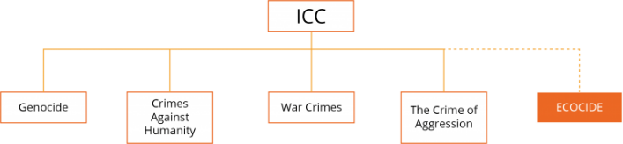
The Rome Statute
The Rome Statute is the treaty that established the ICC. The Rome Statute established four core international crimes: genocide, crimes against humanity, war crimes and the crime of aggression. To add ecocide to this list the Rome Statute has to be amended.
The crimes trialled at the ICC after an ecocide amendment would be adopted.
The amendment of the Rome Statute requires the head of one signatory state to propose the inclusion of ecocide as a crime. Any member state, however small, can propose an amendment and, once three months have passed, it needs a simple majority of members present and voting at the next meeting to take it up. On taken up, it cannot be vetoed. With a two thirds majority the amendment can be adopted and added to the statute. When adopted, states can then ratify the amendment, which comes into force in that state a year after ratification is submitted.
If a state does not ratify the amendment they are nonetheless significantly affected by the adopted amendment, because their nationals can no longer operate ecocidal activities in countries which have ratified and, under universal jurisdiction principles, may be arrested in any ratifying country.

Major Countries and Organizations Involved
United Kingdom
The United Kingdom is a majorly involved country for more than one reason. Firstly because Polly Higgins lived in the United Kingdom. Secondly because when in the 1990s the ICC was set up, ecocide was intended to sit alongside the crimes of genocide, crimes against humanity and war crimes. Ecocide was removed in a closed doors meeting, however papers that have since emerged show that the United Kingdom was one of the countries that had lobbied to have ecocide removed.
Vanuatu
Vanuatu is one of the two sovereign states which have publicly called for consideration of an ecocide amendment.
Maldives
Maldives is one of the two sovereign states which have publicly called for consideration of an ecocide amendment.
The Netherlands
The Urgenda Climate Case against the Dutch Government was the first in the world in which citizens established that their government has a legal duty to prevent dangerous climate change. The District Court of The Hague ruled the government must cut its greenhouse gas emissions by at least 25% by the end of 2020 (compared to 1990 levels). Additionally the Netherlands was one of the countries that had lobbied to have ecocide removed in the 1990s.
France
France was one of the countries that had lobbied to have ecocide removed in the 1990s.
United States of America
The United States of America was one of the countries that had lobbied to have ecocide removed in the 1990s.
China
China is the number one producer of greenhouse gas emissions with a cumulative greenhouse gas emissions from 1988-2015 of 14,32%.

Timeline of Events
Date | Description of event
1948 | The United Nations General Assembly establishes the International Law Commission (ILC).
1970 | The term ‘ecocide’ was first used to name massive damage and destruction of ecosystems.
1972 | The Stockholm Declaration (a declaration containing 26 principles concerning the environment and development) was adopted and a Working Group on Crimes Against the Environment was formed and a draft Ecocide Convention was submitted to the United Nations in 1973.
1991 | The Draft Code of Crimes Against the Peace and Security of Mankind contains 12 crimes. Ecocide was replaced by ‘wilful and severe damage to the environment’.
1993 | The Secretary-General had received 23 replies on the Draft Code of Crimes Against the Peace and Security of Mankind from 1991. Only the Netherlands, the United Kingdom and the United States of America opposed the inclusion of an environmental crime.
1995 | The ILC reduced the 12 crimes to 6. The Draft Code discussions moved to the Sixth Committee of the General Assembly.
17 October 1995 | ‘Wilful and severe damage to the environment’ was removed by the General Assembly Sixth Committee’s 16th meeting. One of the reasons for retaining it was the fact that environmental harm is a state responsibility.
1996 | The issue of environmental crime is tasked to a working-group in the ILC. Canadian/ Australian lawyer Mark Gray published his 1988 proposal for an international crime of ecocide, based on established international environmental and human rights law.
5 July 1996 | The reduced Draft Code of Crimes Against the Peace and Security of Mankind, with only 4 crimes, was adopted on second reading by the ILC.
1998 | The final Draft Code of Crimes Against the Peace and Security of Mankind is renamed as the Rome Statute. The mention of environmental harm is restricted to war-crime only, not a peace-crime.
2002 | The Rome Statute of the ICC entered into force, including only four international crimes of ‘the most serious crimes of concern to the international community as a whole’.
March 2010 | Polly Higgins submitted an ecocide amendment to the United Nations Law Commission.
2017 | Crimes of Aggression was added to the Rome Statute
December 2019 | Vanuatu and the Maldives have publicly called for consideration of an ecocide amendment at the Assembly of States Parties to the Rome Statute
20 December 2019 | The Dutch Supreme Court states that the Dutch government must reduce emissions immediately in line with its human rights obligations.

Relevant UN Treaties and Events
- Establishment of an International Law Commission, 17 November 1947 (A/RES/174(II))
- Formulation of the principles recognized in the Charter of the Nürnberg Tribunal and in the judgment of the Tribunal, 21 November 1947 (A/RES/177(II))
- Declaration of the United Nations Conference on the Human Environment, 5-16 June 1972

Previous Attempts to solve the Issue
Over the years there have been multiple attempts to make ecocide a crime. It started in the 1970s with the Stockholm Declaration which is one of the only proposed codes to be adopted. After that came the Draft Code of Crimes against the Peace and Security of Mankind. In the first draft ecocide was one of the 12 crimes, but as some states opposed to ecocide being a crime it was removed from the Draft Code. The only way in which ecocide is mentioned in the Rome Statute is restricted to war-crimes. This means that the companies and states are still allowed to pollute the environment without being responsible for it. However the Dutch government was held responsible for their actions by their civilians and has to reduce their emissions drastically.
The agreements on an international basis that do exist, do not work because of the fact that there are no consequences if a country decides to ignore it. For example when the United States of America decided to withdraw from the Paris Agreement or when a country makes no effort to reach the set goal.
Most agreements have a long time span, like the Paris Agreement or the UN’s Sustainable Development Goals. This means that there is a long time between the year they are signed and the year the goal is set in. Therefore countries tend to wait till the end of the time period to start with their changes and therefore do not reach the goals at the time they should have reached them.

Possible Solutions
For a solution to work it should be able to be regulated and there should be consequences if countries decide to ignore the agreements that are made.
A possible solution is to make ecocide a crime at the ICC, however we have seen that in recent years this has not led to a lot of progress.
Another way is to make internationally binding agreements like the Paris Agreement, but with clear consequences, if not followed. Another important thing to keep in mind is that if the time span is too long, countries will not feel the need to do something about the problem at the current time and they will postpone their actions.
Therefore I suggest you keep the time span short, or you have countries deliver some sort of action report every (few) year(s). This will make sure that you have an overview of the different measures that have been taken and if consequences have to be set. Additionally this will solve the problem of countries endlessly postponing their actions.

Bibliography
“Award-Winning Author, Barrister & Ecocide Law Expert (1968-2019).” Polly Higgins, https://pollyhiggins.com/.
“Become an Earth Protector.” Stop Ecocide, www.stopecocide.earth/become.
Colville, Rupert. “Bachelet Welcomes Top Court's Landmark Decision to Protect Human Rights from Climate Change.” United Nations Human Rights Office of the High Commissioner, Rupert Colville, www.ohchr.org/EN/NewsEvents/Pages/DisplayNews.aspx?NewsID=25450&LangID=E.
“Global Climate Litigation.” Urgenda, Urgenda, www.urgenda.nl/en/themas/climate-case/global-climate-litigation/.
Griffin, Paul. “The Carbon Majors Database.” CDP Carbon Majors Report 2017, CDP, July 2017, https://b8f65cb373b1b7b15feb-c70d8ead6ced550b4d987d7c03fcdd1d.ssl.cf3.rackcdn.com/cms/reports/documents/000/002/327/original/Carbon-Majors-Report-2017.pdf.
Higgins, Polly. “What Is Ecocide?” Ecocide Law, Polly Higgins, https://ecocidelaw.com/ecocide-law-2/.
Higgins, Polly. “History.” Ecocide Law, Polly Higgins, https://ecocidelaw.com/the-law/history/.
Higgins, Polly. “The Rome Statute.” Ecocide Law, Polly Higgins, https://ecocidelaw.com/the-law/rome-statute/.
Higgins, Polly. “Polly Higgins.” Ecocide Law, Polly Higgins, https://ecocidelaw.com/polly-higgins/.
Jowit, Juliette. “British Campaigner Urges UN to Accept 'Ecocide' as International Crime.” The Guardian, Juliette Jowit, 9 Apr. 2010, www.theguardian.com/environment/2010/apr/09/ecocide-crime-genocide-un-environmental-damage.
Neslen, Arthur. “Dutch Appeals Court Upholds Landmark Climate Change Ruling.” The Guardian, Arthur Neslen, 9 Oct. 2018, www.theguardian.com/environment/2018/oct/09/dutch-appeals-court-upholds-landmark-climate-change-ruling.
Riley, Tess. “Just 100 Companies Responsible for 71% of Global Emissions, Study Says.” The Guardian, Tess Riley, 10 July 2017, www.theguardian.com/sustainable-business/2017/jul/10/100-fossil-fuel-companies-investors-responsible-71-global-emissions-cdp-study-climate-change.
“The International Criminal Court.” International Criminal Court, International Criminal Court, www.icc-cpi.int/about.
“The Urgenda Climate Case Against the Dutch Government.” Urgenda, Urgenda, www.urgenda.nl/en/themas/climate-case/.
“United Nations Conference on the Human Environment.” Wikipedia, Wikipedia, https://en.wikipedia.org/wiki/United_Nations_Conference_on_the_Human_Environment#Stockholm_Declaration.
Watts, Jonathan. “Polly Higgins, Lawyer Who Fought for Recognition of 'Ecocide', Dies Aged 50.” The Guardian, Jonathan Watts, 22 Apr. 2019, www.theguardian.com/environment/2019/apr/22/polly-higgins-environmentalist-eradicating-ecocide-dies.

Appendix or Appendices
- The Rome Statute
https://www.icc-cpi.int/NR/rdonlyres/EA9AEFF7-5752-4F84-BE94-0A655EB30E16/0/Rome_Statute_English.pdf
- Resolution A/RES/177(II), Formulation of the principles recognized in the Charter of the Nürnberg Tribunal and in the judgment of the Tribunal
https://undocs.org/en/A/RES/177(II)
- Resolution A/RES/174(II), Establishment of an International Law Commission
https://undocs.org/en/A/RES/174(II)
- Declaration of the United Nations Conference on the Human Environment (Stockholm Declaration)
https://www.soas.ac.uk/cedep-demos/000_P514_IEL_K3736-Demo/treaties/media/1972%20Stockholm%201972%20-%20Declaration%20of%20the%20United%20Nations%20Conference%20on%20the%20Human%20Environment%20-%20UNEP.pdf
- List of greenhouse gas emissions producers and their cumulative emissions 1988-2019
https://b8f65cb373b1b7b15feb-c70d8ead6ced550b4d987d7c03fcdd1d.ssl.cf3.rackcdn.com/cms/reports/documents/000/002/327/original/Carbon-Majors-Report-2017.pdf

