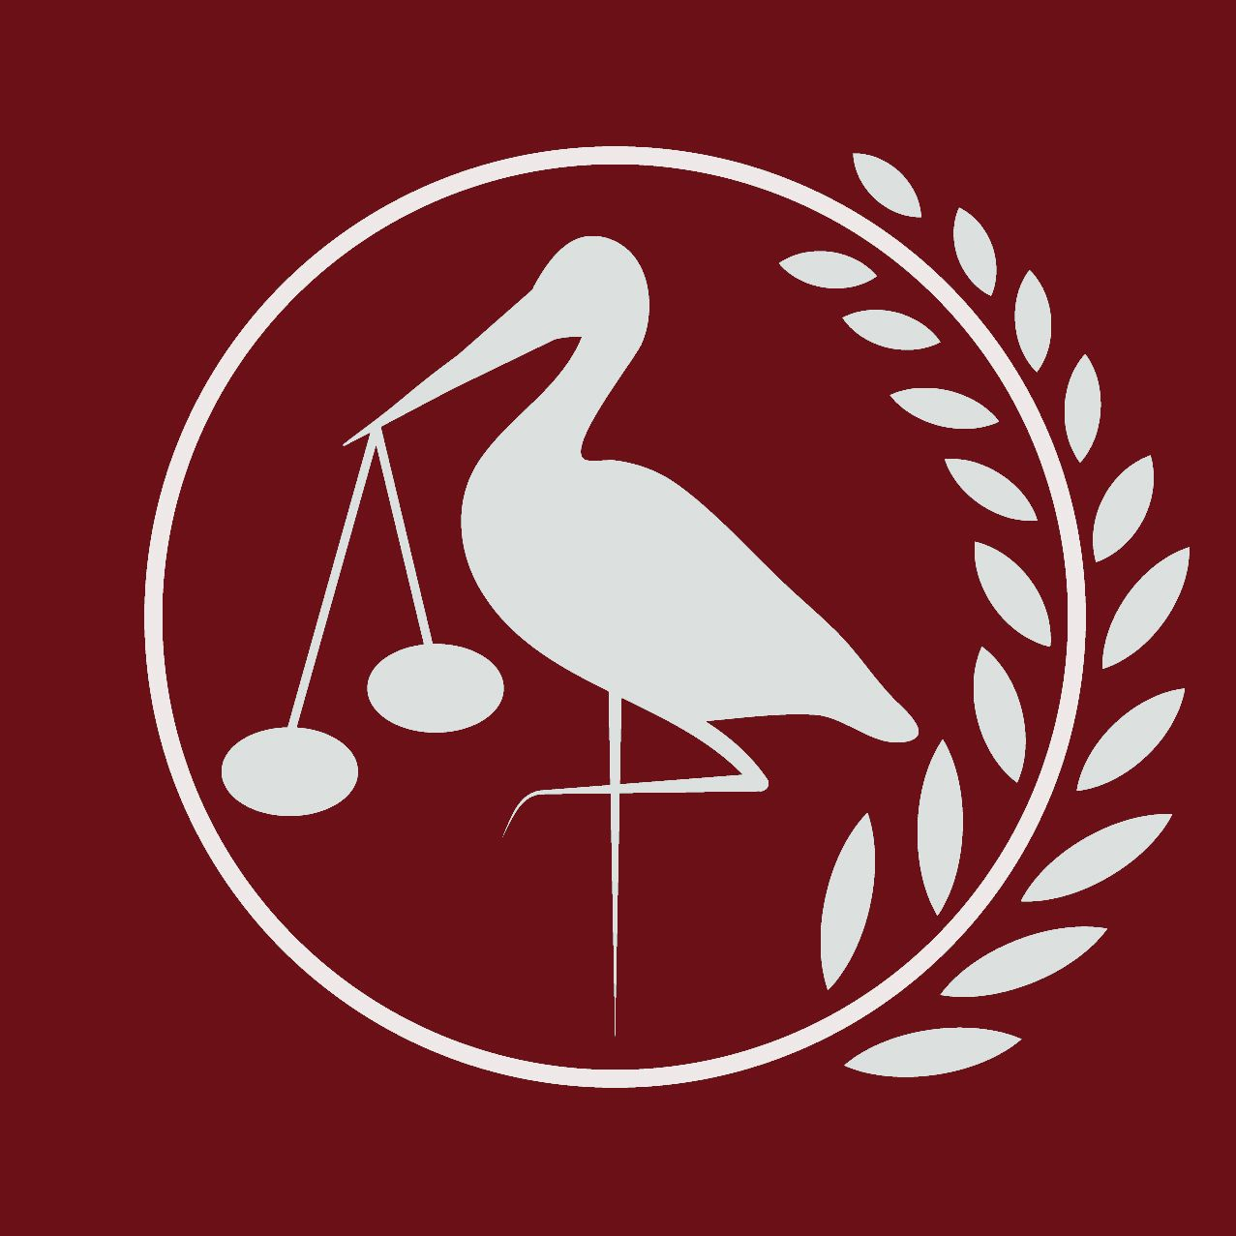
Haganum Model United Nations
Gymnasium Haganum, The Hague
Research Reports

European Council

The curbing of illegal immigration from Northern Africa to the European Union

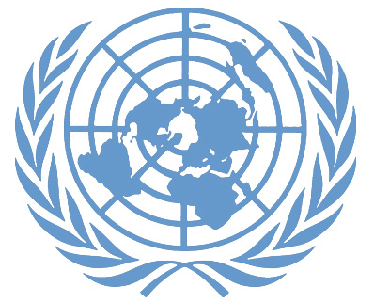

8th, 9th and 10th of March 2019

Forum: European Council
Issue: The curbing of illegal immigration from Northern Africa to the European Union
Student Officer: Raphael Ridder
Position: President of the European Council

Introduction
As war and conflict in the Middle East and Northern Africa continues, thousands of illegal migrants and refugees are coming into Europe to find a better life for themselves. They cross the dangerous Mediterranean Sea on small, overcrowded boats, prone to capsizing and then arrive in a new, foreign land and culture. The European Nations then must accommodate millions of refugees and migrants.
Beginning in 2015, the number of migrants has increased greatly, with Germany taking most of these displaced people, and Italy and France also taking significant numbers. In the first part of 2016, more than 100,000 migrants arrived in Europe each month. However, under the current European Union policy, migrants are allowed to move freely between all the countries in the Union.
These masses of migrants put pressure on the economies of the European Nations, especially those on the Mediterranean Sea, who receive many of these immigrants. Moreover, countries with large “social safety nets” must pay for the benefits available for the newcomers. This economic burden has already strained relations among the European Nations, who have struggled to fairly accommodate and pay for the millions of refugees and migrants that pour into the continents. Countries remain divided on how much they should pay for these non-citizens, especially while many countries, such as Spain and Italy, recover from economic depression. The rise of popular support for far-right parties has been attributed to this spike in immigration.

Definition of Key Terms
Refugee
A refugee is someone who has fled from his country to save their life or preserve their freedom, owing to a well-founded fear of being persecuted for religious, racist, political reasons. A refugee has no protection from their own state - it is often their own government that is threatening to persecute him. The status of refugee has been recognized by the 1951 Convention relating to the Status of Refugees.

Asylum Seekers
Someone who claims to be a refugee, but whose claim has not yet been definitively evaluated. In mid-2014, there were more than 1.2 million asylum-seekers according to the UNHCR.
Migrant
Refugees and migrants are different status, for migrants (and especially economic migrants) choose to move in order to improve the future prospects of themselves and their families. Refugees and migrants are treated very differently under international law.
Returnee
Someone forced from his home voluntarily deciding to return home. This can be, according to the UNHCR, a solution for refugees if their home is at peace again.
Internally Displaced
Someone who remains displaced by conflict within his own homeland: unlike a refugee, an internally displaced person has not crossed a state border and remains under the protection of their own government.

Background Information

The start of the crisis
The issue started when the Arab Spring broke out in 2011, due to the fact that many people from these nations felt extremely unsafe in their own nation. The first refugees appeared hereafter in Europe. However, due to the nature of this conflict not a vast number of refugees reported themselves in Europe. Many stayed to fight the unfair regime that had tyrannised them for decades.

It was only after the Islamic State (IS) got a great foot hold in Syria due to the national unrest that more and more refugees started to appear in Europe. IS held a vast amount of land for many years, where they oppressed the more forward-thinking nationals. Therefore, many Syrian nationals fled and sought refuge in European or neighbouring nations. This is when the refugee crisis reached its most critical point.

Changed European stance
Germany was the first European nations that took in millions of refugees, whit whom they filled their “ghost cities”. even after great demonstrations in Germany Chancellor Angela Merkel was the European leader that took the lead in the handling of the refugee crisis. However, she later recognised that it was impossible for a nation to take in all the refugees that reported themselves. She hereafter decided to limit the Germany intake of refugees. Many other European nations followed her lead and took the same stance, leaving many refugees stranded on Greek islands, where they were stranded after the extremely dangerous journey.

The European union has made many precautions to protect themselves from illegal entering of the Union. Per example the deal with Turkey, the ‘one in, one out’ deal, which most simplistically states that one Syrian refugee found on a Greek island will be returned to Turkey and one Syrian asylum seeker will be found a home in Europe. This was seen as a major breakthrough by European leaders, seeing that this would inhibit the illegal crossing of the Mediterranean Sea.

The current objectives
After the harder stance of Europe and the closer protecting of the borders more and more refugees result to the use of human traffickers, that will help them across the Mediterranean Sea. These human trafficking gangs are getting in more and more conflict due to the fact that this business is extremely profitable. The refugees often feel that they have no other choice than crossing the border illegally, due to the extreme amount of border protecting regulations that are made.

It is evident that the South-European nations take most of the strain, due to European Law that states that refugees need to be housed in the nation, in which they enter. Current public opinion is, therefore, that the EU needs to adapt this regulation not only for the South-European nations but also for the refugees. Many refugees are not able to be rightly housed, because of the vast number in which the enter these nations.

European nations also see opportunities to halt the refugees before the cross the Mediterranean Sea. This is for many European nations the current objective. Most logically this is what will help solve the refugee crisis in Europe seeing that the problem lays in the number of refugees for right processing. With European aid there could be good refugee camps set up in Northern-African nations. This would tackle the root of the crisis for Europe and will also give refugees better opportunities and living-standerds.

Major Countries and Organizations Involved

Syria
Today, nearly 12 million Syrians, more than half of the total population, have been forced from their home since the beginning of the crisis. According to the UN Refugee Agency, 51% of the refugees attempting to reach Europe are Syrian.
In Syria, the population faces several dangers: the government, the rebels fighting against the government and IS forces. Most of the Syrian refugees have fled to neighbouring countries: Lebanon, Jordan, Turkey and Iraq, and most have ended up in camps. According to the UNHCR, less than 10% of Syrians who have fled the conflict have sought safety in Europe.

Turkey
According to UNHCR, it became the top host country in 2014 with almost 1.9 million refugees due to proximity to Eastern Africa and Middle-East, the refugees do not have to endure a long and risky journey. Secondly, Europe remains a ‘paradise’, and Turkey is thus the major point of departure for refugees trying to cross into Greece or those who make their way through Western Balkans. Therefore, it is dire for the EU to uphold good relations with Turkey.

UNHCR
The United Nations High Commissioner for Refugees (UNHCR) was founded in 1950, during the aftermath of the Second World War, to aid millions of Europeans who were forced to flee or lost their homes. It was originally decided that the UNHCR would disband after their exemplary work in Europe. However, 68 years later it still tackles world-wide refugee issues.

Since the start of the 21st century the UNHCR has been the world-wide backbone to humanly handle refugee crises. The UNHCR has been asked to utilise its expertise in aiding internally displaced people and stateless people. The UNHCR now is a major humanitarian organisation with more than eleven thousand staff members and a budget of $6.54 billion dollars. After this tremendous growth it has been able to aid well over fifty million refugees in our 65-year lifespan. Due to its ground-breaking work on refugee crisis handling it will always be a great helping hand in handling refugee crises.

Timeline of Events
Date | Description of event
1950 | Creation of the UNHCR
1951 | Convention related to the Status of Refugees
2011 | Arab Spring
2013 | Dublin III Regulation instated
2014 | Syria becomes the main country for refugee applications in the EU

Relevant EU Treaties and Events
- Dublin regulation, 2013, 604
- The EU- Turkey refugee agreement, 18th of March 2016
- Dublin regulation, 2013, 604 The need to reform European migration policies, 26th of January 2017, 2147

Previous Attempts to solve the Issue
There have been many attempts to tackle this issue in Europe with the Dublin regulation and the deal ‘one in, one out’ deal with Turkey being the most prominent one. The EU has taken a harder stance against the enormous mass of refugees they are able to take in. This resulted in a more complex network of human trafficking into and within Europe. Many housing possibilities for refugees have been used and due to the mass of refugees at this moment many nations are not able to rightly house refugees. Taking the refugees in vast amounts in has been the most prominent previous solution.

Possible Solutions

The first solution one could consider is to implement a quota on the amount of rehires a EU member states could house in good order. This would help with national unrest about the fact that some small villages are housing more refugees than their number of inhabitants.

Furthermore, one could consider lobbying for a better distribution of the immigrants, seeing that the Dublin Regulation indicates that refugees are to be hosted in the first nation they register them self. This will help with the fact that many coastal nations are overwhelmed with the number of refugees report them self in their country.

One could also look towards action against the human trafficking over the Mediterranean Sea. One would need to seek help from Northern-African nations to join forces against the human trafficking across this sea. This would tackle the root of the problem more than just only look at the consequences. One would also need to take into account the consequences this might have on the Northern-African nations and aid them with taking in refugees

Bibliography
(UNHCR), United. 2016. "UNHCR Syria Regional Refugee Response". UNHCR Syria Regional Refugee Response. http://data.unhcr.org/syrianrefugees/country.php?id=224.
"Europe Refugee Crisis: Hungary Calls On EU For $3.4B Financial Aid Package To Syria's Neighbors". 2015. International Business Times. http://www.ibtimes.com/europe-refugee-crisis-hungary-calls-eu-34b-financial-aid-package-syrias-neighbors-2094021.
"The Challenge Of The Syrian Refugee Response". 2016. US News & World Report. http://www.usnews.com/news/articles/2015/01/09/syrian-refugee-crisis-challenges-international-aid-organizations.
"What Kind Of Support Do Government-Assisted Refugees Get?". 2016. Cic.Gc.Ca. http://www.cic.gc.ca/english/helpcentre/answer.asp?qnum=098&top=11.
"European Commission - PRESS RELEASES - Press Release - EU Support In Response To The Syrian Crisis". 2016. Europa.Eu. http://europa.eu/rapid/press-release_MEMO-16-222_en.htm.
"Funding To Syrian Crisis 2016". 2016. Fts.Unocha.Org. https://fts.unocha.org/pageloader.aspx?page=special-syriancrisis.
"What You Need To Know About The Syrian Refugee Crisis And What The U.S. Is Doing To Help". 2015. Whitehouse.Gov. https://www.whitehouse.gov/blog/2015/09/15/what-you- need-know-about-syrian-refugee-crisis-and-what-us-doing-help.
Henley, Jon. “What Is the Current State of the Migration Crisis in Europe?” The Guardian, Guardian News and Media, 21 Nov. 2018, www.theguardian.com/world/2018/jun/15/what-current-scale-migration-crisis-europe-future-outlook.
Maclean, Ruth. “EU's New Refugee Policy under Fire as Children Stuck in Limbo in Niger | Ruth Maclean.” The Guardian, Guardian News and Media, 1 July 2018, www.theguardian.com/world/2018/jul/01/refugees-niger-africa-eu-summit-border-policy-migrant-children.

Kingsley, Patrick, and Jennifer Rankin. “EU-Turkey Refugee Deal – Q&A.” The Guardian, Guardian News and Media, 8 Mar. 2016, www.theguardian.com/world/2016/mar/08/eu-turkey-refugee-deal-qa.

“Closing of Borders in Europe Is the Wrong Way to Go.” DRC, 4 Jan. 2017, https://drc.ngo/news/news-archive/closing-of-borders-in-europe-is-the-wrong-way-to-go.

Appendix or Appendices
- Anonymous. “Country Responsible for Asylum Application (Dublin).” Together Against Trafficking in Human Beings, 6 Dec. 2016, https://ec.europa.eu/home-affairs/what-we-do/policies/asylum/examination-of-applicants_en.

- “The EU-Turkey Deal: Explained.” Help Refugees, 26 Oct. 2018, https://helprefugees.org/news/eu-turkey-deal-explained/.

